RTO No. 31736 | CRICOS Provider No. 03010G

Credit Transfer Policy and Procedure

Brisbane Campus (Head Office)  Level 2, 359 Queen Street  Brisbane QLD 4000  Australia  +61 7 3221 1626  info@queensford.edu.au | Fitzwilliam Street Campus, Parramatta  Level 3, 1 Fitzwilliam Street  Parramatta NSW 2150  Australia  +61 2 8640 0040  info@queensford.edu.au
Wentworth Street Campus, Parramatta  Level 5, 9 Wentworth Street  Parramatta NSW 2150  Australia  +61 2 8640 0040  info@queensford.edu.au | Adelaide Campus, Parramatta  Level 11, 90 King William Street  Adelaide SA 5000  Australia  +61 8 8410 4605  sa@queensford.edu.au
Version control
Date | Version | Changes made | Author
11 Oct 2018 | V1.0_GD | Released for comment | Gay Doyle
10 Jan 2020 | V1.1 | Updated policy and procedures in line with the National Code 2018 | Shashank Vuppala
09/2020 | v1.2 | updated with new policy template and content review | Compliance Dept
12/2021 | V2.0 | Updated the process, associated documents, overall content and inserted the CT Process flowchart | Kishor Adhikari

Copyright © 2020 Malekhu Investments trading as Queensford College. All rights reserved.
ABN 17 129 064 437 | RTO 31736 | CRICOS Provider No. 03010G | www.queensford.edu.au

Contents
1. Purpose 4
2. Scope 4
3. Responsibility 4
4. Compliance/legislation 4
5. Definitions 4
6. Policy 5
7. Procedure 6
8. Fees 11
9. Recording and Reporting 11
10. Complaints and Appeals 11
11. Associated Documents 11

Purpose
The purpose of this policy and procedure is to ensure that students are not required to repeat any unit or module in which they have already been assessed as competent unless a regulatory or licence requirement restricts this provision. The National VET System requires that all nationally endorsed qualifications, skill sets, and units of competency must be recognised regardless of where they are issued within the country. This policy and procedure document outlines the process for assessing Credit Transfers including authenticating the evidence provided by the student, prior to granting approval.

Scope
This policy applies to all VET Qualification on Queensford College’s scops pf registration and students enrolled/seeking to enrol with Queensford College’s courses of study and outlines the conditions under which Credit Transfer will be granted.

Responsibility
The RTO Manager is responsible for the development, implementation, review and improvement of this policy and procedure. Additionally, staff within the RTO Compliance Department and staff involved in student enrolment/administration will be responsible for implementing tasks relevant to this policy and procedure.

Compliance/legislation
Clause/standard | Requirement
Clause 3.5 of the Standards for RTOs 2015 | The RTO accepts and provides credit to learners for units of competency and/or modules (unless licensing or regulatory requirements prevent this) here these are evidenced by:  a) AQF certification documentation issued by any other RTO or AQF authorised issuing organisation; or  b) authenticated VET transcripts issued by the Registrar.

Definitions
AQF Australian Qualifications Framework. means the framework for regulated qualifications in the Australian education and training system, as agreed by the Commonwealth, State and Territory ministerial council with responsibility for higher education.
CoE Confirmation of Enrolment. The CoE provides evidence of a student’s enrolment with a provider registered on the Commonwealth Register of Institutions and Courses for Overseas Students (CRICOS). This evidence is required before Home Affairs will issue a student visa. The CoE contains information about the Provider, agent (if involved), course and duration of study in which the student has enrolled.
Credit transfer (CT) is a process that provides student with agreed and consistent credit outcomes for components of a qualification based on identified equivalence in content and learning outcome between matched qualifications.
PRISMS The Provider Registration and International Student Management System (PRISMS). PRISMS is a secure database owned and maintained by the Department of Education and Training for the purposes of administering the Education Services for Overseas Students Act 2000 (The ESOS Act).
RPL Recognition of Prior Learning. RPL means an assessment process that assesses the competency/s of an individual that may have been acquired through formal, non-formal and informal learning to determine the extent to which that individual meets the requirements specified in the training package or VET accredited courses.
RTO Registered Training Organisation
Statement of Attainment A statement issued to a person confirming that they have satisfied the requirements of a specified unit or units of competency.
Unit of Competency The specification of the standards of performance required in the workplace.
USI Unique Student Identifier. A USI is students’ individual education number for life. It also gives students/student authorised education providers an online record of the student’s VET training undertaken in Australia.
VET Vocational Education and Training

Policy
  - Queensford College is committed to providing all potential and current students with the opportunity for credit transfer for studies completed previously at an RTO or any other authorised issuing organisation such as a university in Australia.

  - Queensford college will provide students with adequate information and assistance for the Credit Transfer process which will include:
- Access to Queensford College’s Credit Transfer Policy and Procedure on the website;
- adequate information and support to enable them to gather evidence for the process including completion of the Credit Transfer Application Form, Submission of Statement/s of Attainment, Transcript/s and provision of USI Authorisation to Queensford College.
  - Queensford College recognises the following documentation:
- A Qualification issued under the Australian Qualification Framework including the following details: name, code and logo of issuing body, name of person receiving the qualification; nomenclature as in the Framework; date issued; authorised signatory.
- A Statement of Attainment or formal Award Element List issued under Australian Qualification Framework including the following details: name of the person who achieved the competencies; date issued; national code and name for each unit of competency achieved, the Nationally Recognised Training logo.
  - Queensford College does not automatically grant Credit Transfer on the basis of application and documentary evidence provided by the student but rather conducts an authentication process by directly accessing the USI transcript online or by contacting the organisation that issued the document. The Credit Transfer application will be rejected if the documents are not able to be authenticated either via USI transcript or verification by the issuing organisation.
  - Queensford College is not obliged to issue a qualification or statement of attainment that is achieved wholly through recognition of units and/or modules completed at another RTO or RTOs.
  - Queensford College may not grant credit if a licensing or regulatory requirement prevents the unit being awarded through a credit process.
  - In some instances, awarding Credit Transfer for an imported elective unit may not be suitable if it does not fit in within the selected units for delivery and is not relevant to the vocational (industry or work) outcome of the program. The decision to not award Credit Transfer will only be taken after consultation with the student and their trainer.
  - Where units that do not have an equivalent outcome, however components of a unit are corresponding, recommendations may be made to the student to undertake assessment via the Recognition of Prior Learning (RPL) pathway.
  - Credit Transfer applications must be submitted at the enrolment stage prior to course commencement. This enables Queensford College to ensure the individual training needs of the student and will inform the selection of units and duration of the course.
  - However, in the rare instance that a student presents the College with a Credit Transfer Application while the course is in progress, the Credit Transfer application will still be accepted for review, but the late application may have impact on the student fees.
  - Fees and charges for Credit Transfer vary for international/domestic fee-for-service students and domestic students funded by each State.

Procedure
Stage 1: Application
Responsibility: Applicants, Student Services/Admissions team
  - Queensford College encourages prospective students to provide Credit Transfer applications (Completes Section A, B and D) along with the Student Application form at least two weeks prior to enrolment as the number of credit transfers granted directly impacts course duration, delivery timetables and course fees. Therefore, prospective students are required to indicate on their student enrolment/application form that they are seeking Credit Transfer/s.
  - If the applicant selects CT on the application form Under the section “Recognition of Prior Learning or Credit Transfer”, they need to complete the “Credit Transfer Application and Review form’ and complete relevant sections.
  - Alternatively, Student Services/Admissions department can provide the student with a Credit Transfer Application and Review Form and instructions to provide USI authorisation to Queensford College to enable USI transcript checks.
  - The student will submit the completed and signed Credit Transfer Application and Review Form along with the supporting document (for e.g., academic transcripts, statement of attainments from the provider with whom they gave complete the qualification/unit so competency)
  - Evidence must include clear, legible scanned documents. Photos of the certificate taken on a smart phone or snipped extracts of the testamurs will not be accepted.
  - The student provides authorisation to Queensford College to access their USI transcript for authentication checks using the information under section G of the Credit Transfer Application and Review form- USI Authorisation Instruction Guide.
  - Credit transfer application forms completed by a third party (for example, Education Agents) on behalf of the student will not be accepted.

Stage 2: Authentication
Responsibility: Student Services/Admissions team
  - On receipt of the Credit Transfer Application, Student Services/Admissions staff reviews the documents for completeness and then conduct the USI Transcript Check to ensure the authenticity of evidence provided to support Credit Transfer.
  - If the USI transcript does not reflect the units of competency in the application or student has not provided the authorization to access the USI transcripts, Student Services/Admissions staff conducts a verification check with the issuing RTO using the Queensford College RTO Verification Check Template.
  - Student Services team/Admissions team immediately sends a verification email to the certificate issuing provider and or make a telephonic call once it received the signed Credit Transfer Application and Review form.
  - Either verification of USI transcripts online or verification of the information with the issuing RTO is sufficient.
  - Student Services/Admissions team reviews upcoming timetables for the courses to determine if there is a possible group/batch/intake that will be suitable for the student considering the reduced number units of competency the student will need to complete once Credit Transfer is approved.
  - However, the Student Services/Admissions team will not finalise the timetable until the CT has been approved by the Compliance department but may forward the information to the reviewing officer or the Compliance department.
  - Student Services/Admissions team completes the verification process for the documents submitted to support the Credit transfer request and sends it to the designated Trainer/Assessor/Reviewer along with the Credit Transfer Application and Review form. In the absence of the designated Trainer/Assessor/Reviewer, this request is forwarded to the Compliance Department.
  - Student Services/Admissions team completes the applicable sections in the International Student Admissions Checklist as they proceed with the application from the time of receiving the application to completing the enrolment and section F in the Credit Transfer Application and Review form before sending them to the Trainer/Assessor/Reviewer or to the Compliance department.
  - In rare instances where Credit Transfer applications are received only a few days prior to the course commencement, and/or the USI Transcript checks do not indicate the units of competency applied for Credit Transfer, Student Services will conduct a verification check with the issuing RTO.
  - However, if the issuing RTO is not able to respond before course commencement, then Queensford College may enrol the student with a Letter of Offer indicating Provisional Credit Transfer for the units of competency applied. The Provisional Credit Transfer is subject to a successful verification check being obtained from the student’s issuing RTO.
  - If the verification check is unsuccessful, the student will be required to complete all the units (core and electives) required for the qualification and the revised letter of offer and CoE will be issued accordingly.

Stage 3: Assessment and the Outcome of the Credit Transfer Application
Responsibility: Trainer/Assessor/Compliance Department
  - Trainer/Assessor/Reviewer reviews the application and its supporting documents against qualification packaging rules and desired outcome for the course.
  - In some instances, awarding Credit Transfer for an imported elective unit may not be suitable if it does not fit in within the selected units for delivery and is not relevant to the vocational (industry or work) outcome of the program or not allowed by the packaging rule.
  - In the case of any superseded and non-equivalent units of competency, Trainer/Assessor/Reviewer provides rationale and analysis to determine the equivalence of the study completed with the relevant units or modules before/if granting any credit (If applicable).
  - Trainer/Assessor/Reviewer or the Compliance department completes the relevant section on the Credit Transfer Application and Review form, makes decisions on the request and creates a customised timetable if the request is successful.
  - Compliance Department completes the Section C and E of the Credit Transfer Application and Review Form with information that includes Credit Transfer units of competency and the remaining units required to be completed by the student for completion of the qualification.
  - The completed Credit Transfer Application and Review form is sent to Student Services/Admissions department.

Stage 4: Offer Letter, Enrolment and Communication
Responsibility: Student Services/Admissions team
  - Student Services will calculate the applicable fees/course duration and prepare a letter of offer for the student. The student will be advised in writing of approval or denial of application. Student Services will issue a letter of offer reflecting the Credit Transfers approved, course duration and fees.
  - Student Services Department/Admissions department creates offer letter taking into consideration the credit transfer decision made by the trainer/Assessor/Reviewer or the Compliance department and sends to the students.
  - If the CT are assessed and applied after the commencement of the course, the letter of offer still need to be revised and the CoE revised in case of international student with a revised duration if there are any changes in the duration du to the Credit transfer. Additional fee may apply as per the fees section of this policy.
  - Student accepts the letter of offer and agreement or offer to study at Queensford College and signs the necessary documents and submits to Queensford College Admissions/Student Services department. Student makes the necessary payments if applicable as per the letter of offer and agreement.
  - Student Services/Admissions department provide information to the Data Officer for addition of the student on the Student Database Management System under the relevant course.
  - Student enrolled into the course and relevant unit. Confirmation of Enrolment sent to the student along with the timetable.
  - Student Services/Admissions completes the section F of the Credit Transfer Application and Review form and records the information.
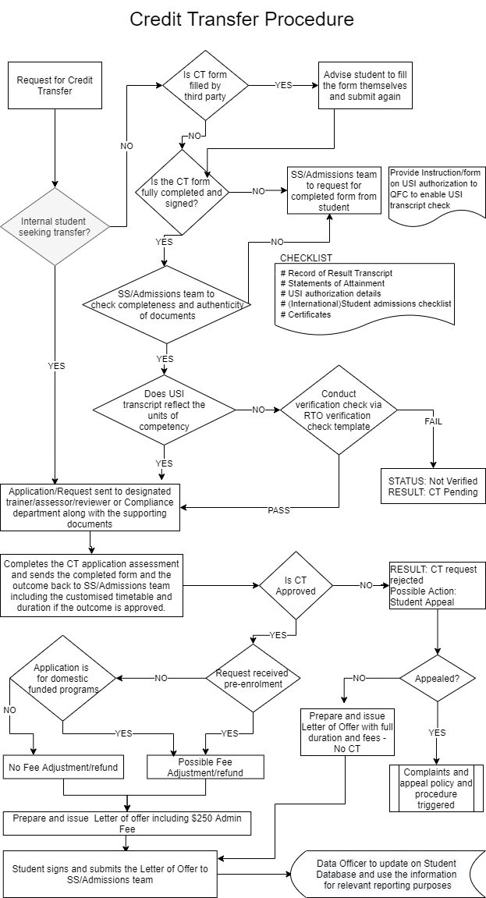

Fees
Credit Transfer will attract administration fees of $250; however, there will be no charges/tuition fees applied to the units of competency granted as Credit Transfer if the application is submitted prior to or during the enrolment not after the commencement if the course. In addition, following conditions apply:
  - Students from domestic funded programs are not charged any fee for units granted as Credit Transfer. Hence, if they submit a Credit Transfer application after commencement of their course, they will be refunded fees previously charged/paid for units of competency that have been granted as Credit Transfer after assessment of the Credit Transfer application.
  - Queensford College does recognise that in some instances, students may provide a Credit Transfer application well after their course has commenced. Queensford College will assess the Credit Transfer application; however, in this instance, for fee-for-service/international students, there will be no adjustment of fees or refund of the fees if the Credit Transfer application is received and approved after their course has commenced.

Recording and Reporting
All completed student Credit Transfer Record are maintained in the student profile in the Student Management System. All templates and documents associated to this policy and procedure are maintained in the Document Management System.
This type of credit is reported on the (NAT00120) Enrolment file for the component of study (subject, unit of competency or module) with an outcome code of 60 – Credit transfer. The activity start date and activity end date is the date when the credit transfer is administratively processed by Queensford College.

Complaints and Appeals
If the student is not satisfied with the outcome of the Credit Transfer process, or if their credit transfer request is denied, the student is able to access the complaints and appeals process as outlined in the Complaints and Appeals Policy and Procedure available on the website.

Associated Documents
- International Enrolment Form
- Domestic Enrolment Form
- Credit Transfer Application and Review Form
- International Student Handbook
- Complaints and Appeals Policy and Procedure
- Fees Payment and Protection Policy
- Queensford College RTO Verification Check Template
- USI Authorisation Instruction Guide & Verification Permission
- International Student Admissions Checklist

