RTO No. 31736 | CRICOS Provider No. 03010G

Learner Transition Policy and Procedure

Brisbane Campus (Head Office)  Level 2, 359 Queen Street  Brisbane QLD 4000  Australia  +61 7 3221 1626  info@queensford.edu.au | Fitzwilliam Street Campus, Parramatta  Level 3, 1 Fitzwilliam Street  Parramatta NSW 2150  Australia  +61 2 8640 0040  info@queensford.edu.au
Wentworth Street Campus, Parramatta  Level 5, 9 Wentworth Street  Parramatta NSW 2150  Australia  +61 2 8640 0040  info@queensford.edu.au | Adelaide Campus  Level 11, 90 King William Street  Adelaide SA 5000  Australia  +61 8 8410 4605  sa@queensford.edu.au

Hobart Campus
Level 1, 86 Collins Street
Hobart TAS 7000
Australia
+61 3 6169 9595
tas@queensford.edu.au

Version control
Date | Version | Changes made | Author
Sep 2021 | V1.0 | Policy created | K Adhikari
Jun 2022 | V1.1 | Minor change Section 5.8 – Information to be passed on to Accounts regarding new qualification product code | L D’Silva
Aug 2022 | V2.0 | -Added 5.1, 5.6, 5.8, 5.13, 5.15, 5.16, 5.22, 5.23, 5.24, 5.25, and 6.5  -Added Hobart campus address | K Adhikari

Copyright © 2020 Malekhu Investments trading as Queensford College. All rights reserved.
ABN 17 129 064 437 | RTO 31736 | CRICOS Provider No. 03010G | www.queensford.edu.au

Table of Contents
1. Purpose 4
2. Scope 4
3. Responsibility 4
4. Policy 4
5. Transition Process 6
6. Transition Preparation 8
7. Definitions: 10
8. Associated documents 10
9. References and relevant regulations 11

Purpose
The policy and procedure document is created to assist Queensford College to ensure the students are transitioned to the updated training product or provided with an option to complete the qualification in the event of changes in the training package.
Standard for RTOs 2015 requires, subject to “The requirements specified in clause 1.26 (a) do not apply where a training package requires the delivery of a superseded unit of competency” and unless otherwise approved by the VET Regulator, Queensford College to ensure that:
- where a training product on its scope of registration is superseded, all learners’ training and assessment is completed and the relevant AQF certification documentation is issued or learners are transferred into its replacement, within a period of one year from the date the replacement training product was released on the national register
- where an AQF qualification is no longer current and has not been superseded, all learners’ training and assessment is completed, and the relevant AQF certification documentation issued within a period of two years from the date the AQF qualification was removed or deleted from the national register
- where a skill set, unit of competency, accredited short course or module is no longer current and has not been superseded, all learners’ training and assessment is completed and the relevant AQF certification documentation issued within a period of one year from the date the skill set, unit of competency, accredited short course or module was removed or deleted from the national register
- a new learner does not commence training and assessment in a training product that has been removed or deleted from the national register.

Scope
This policy and procedure applies to:
  - All Queensford College Staff involved in the planning and implementation of transition arrangements
  - Queensford College students (international and domestic) impacted by the transition to the training package they are currently enrolled in
  - All VET qualifications on Queensford College’s scope of registration.

Responsibility
RTO & Compliance Manager is responsible for this policy. Course Coordinators and the Associate Director- Strategy and Growth (Marketing, Recruitment and Student Experience) are responsible for execution of the policy in the event of the changes in the training package(s).

Policy
Queensford College is guided by the General Direction made under section 28(1) of the National Vocational Education and Training Regulator Act 2011 (the Act) to comply with the VET Quality Framework and other conditions of registration as defined in the act.
When there are changes in any of the training products that are on its scope, Queensford College endeavours to act reasonably within the allowed timeframe to the changes in the training product, i.e., superseded training products, deleted training products.
  - Compliance department staff are required to have subscription to update notifications from National Register, training.gov.au. Staff can subscribe to email notifications by creating an account on training.gov.au, and receive automatic notifications about:
- changes to training packages
- qualifications
- units of competency
- skill sets
- accredited courses.

Staff can also subscribe to receive notifications about changes to Queensford College (e.g. when Queensford College adds an item to its scope or changes its contact details).
  - Relevant staff are notified of the changes in the training products/qualifications and meeting is called by the RTO & Compliance Manager to discuss changes and the transition plan.
  - Students impacted by the transition to the training product will be advised on an individual basis and required to provide their signed consent to the transition arrangements.
  - Queensford College transfers the student into the new training product as soon as arrangements including addition of the qualification to scope of registration, updated training/assessment resources, trainer’s matrix, timetables and relevant documents are in place for the transition process. Students who are nearing the end of their course and may be disadvantaged by transitioning into the new qualification, may opt to continue progress and completion in the superseded qualification within the transition period of 12 months or more if ASQA has published an extension period.
  - Queensford College ensures training and assessment is completed for all learners and the relevant AQF certification documentation issued within a period of two years from the date the AQF qualification was removed or deleted from the national register for the training products that are removed and not superseded by a new training product.
  - Queensford College ensures training and assessment is completed for all learners and the relevant AQF certification documentation issued within a period of one year from the date the skill set, unit of competency, accredited short course or module was removed or deleted from the national register for the skill set, unit of competency, accredited short course or module that are removed and not superseded.
  - Queensford College ensures that no new learners are enrolled into the superseded training product after the transition period has expired.
  - Queensford College ensures that it does not issue a qualification or statement of attainment for the superseded training product (except as a replacement for a previously issued qualification or statement of attainment) after the date ASQA removes the superseded training product form Queensford College’s scope of registration.

Transition Process
When the national register publishes new training product(s) that supersedes the qualification(s) on its scope of registration, RTO & Compliance Manager generates the report, with the help of Data and Reporting Officer, on the students that are enrolled in the superseded training product(s) and formulates a Transition Plan in consultation with the student Services department to transfer the students from superseded training products to the new training product(s) in line with the General Direction made under section 28(1) of the National Vocational Education and Training Regulator Act 2011 (the Act).
Stage 1
  - Superseded qualification will be continued to be delivered during the transition period.
  - Communication is drafted and sent out to all the relevant staff and students. Notification is sent via student management system and the Queensford College e-mail system.
  - Meeting is conducted with all Campus Managers/Coordinators, and everyone is informed of the changes in the training package including the transition period and various type of updates made to the training products(s).
Stage 2
  - Analysis of the changes and the student data in undertaken and impact on student(s) is determined and the date for transition is decided.
  - Full analysis and a review of the new training product changes, new requirements, new unit of competencies and the training package Companion Volume Implementation guide on the national register is conducted, and the gaps in the training and assessment tools analysed (between superseded and new unit of competencies).
  - The impact of these changes may have on Queensford College’s licensing, resourcing, equipment, learning and assessment strategies and capacity to deliver is assessed.
  - Transition plan is created for each cohort of student enrolled into the superseded training product(s)
  - In case of international students, the transition may have impact on their CoE duration. Therefore, a full analysis of the impact is assessed for each student.
  - Training Resources and assessment tools update/development/acquisition plan is formulated.
Stage 3
  - Relevant staff and departments are advised of the plan to develop training and assessment development plans in line with the transition date and timelines.
  - The Accounts Department must be notified of changes to course codes so that the relevant XERO product code can be updated in the system.
  - Relevant students are advised of the transition plan including the information that either the qualification must be completed within the transition period, or they must transition to the new qualification. All the communications are performed via student management system.
  - International students are also informed that they may be issued with a new Confirmation of Enrolment (CoE) with a new course end date if the superseded qualification cannot be delivered within transition period and they are transitioned into the replacement training product.
Stage 4
  - If the new training product(s) is non-equivalent, the academic department initiates the scope application process and remove the superseded product with the transition period. Superseded training product(s) are removed from Queensford College’s scope of registration at the expiry of transition period and no student will be enrolled in the superseded training product(s)
  - If the superseded course(s) are still advertised on the website and via marketing collaterals, following information: “This course is superseded. If students commence the course and the course extends beyond the transition period, the “Learner Transition Policy and Procedure” apply, and students may need to be transferred to the replacement course before the end of the transition period.” is inserted in the course section for the prospective student to view and make an informed decision.
  - If a letter of offer is issued for a superseded qualification (issued because either the course can be completed within the transition period and/or there is a transition plan in place to a replacement training product), it should inform student that:
    - the course is superseded, and;
    - if they commence the course and the course extends beyond the transition period, the “Learner Transition Policy and Procedure” apply, and;
    - they may need to be transferred to the replacement course before the end of the transition period.
  - All the resources and marketing collaterals including student handbook and website are updated for the equivalent training product(s). For the new non-equivalent training product(s), the resources and marketing collaterals including student handbook and website are updated after the new courses are published in the national Vet register and the
  - Training and Assessment Strategy document(s) are updated, and training resources and tools acquired or planned to acquire within a reasonable timeframe.
  - Validation of the training and assessment tools, strategy and the training resources are conducted and documented.
Stage 5
  - Students are transitioned into the new training product within the transition period, or they complete the superseded qualification within the transition period.
  - Even if the students are enrolled into the superseded training product(s) during the transition period, they will be transitioned to the new training product(s) as soon as the training product in on the Queensford College’s scope of registration.
  - International students are issued with a new CoE if required.
  - If the students do not want to continue and/or are not ongoing, their enrolments will be withdrawn.
  - If the Qualification is deleted, the training and assessment for existing student is completed within 24 months and qualification or statement of attainment is issued.
  - There will not be further student enrolments and no qualifications or statement of attainment will be issued in the removed/deleted training product after they are removed from scope of registration at the end of transition period.

Transition Preparation
While preparing for transition Queensford College (and or the relevant department):
  - reviews the revised training package and supporting documentation, for example, the companion volume implementation guide on the national register.
  - assesses any requirements in the training package documentation that may have changed, such as licensing implications, resource and equipment lists, learning strategies and assessment guidance.
  - examines its organisation’s resources to ensure it can meet all the new training package requirements.
  - revises its organisation’s training and assessment strategies to ensure they reflect the delivery of the new training package.
  - Transition Checklist on ASQA website can be used as a guide while preparing for the transition: How to transition | Australian Skills Quality Authority (ASQA) (accessed on 18/08/2022).
Transition Communication:
  - communicates to the academic and compliance department staff as soon as the notification is received from the national register, to discuss the changes and discuss the transition strategy
  - communicates to the students of the updates and advises them if/how they are affected and provides them with the option to complete the qualification within the transition period if reasonable or transition them to the new training package as soon as possible.
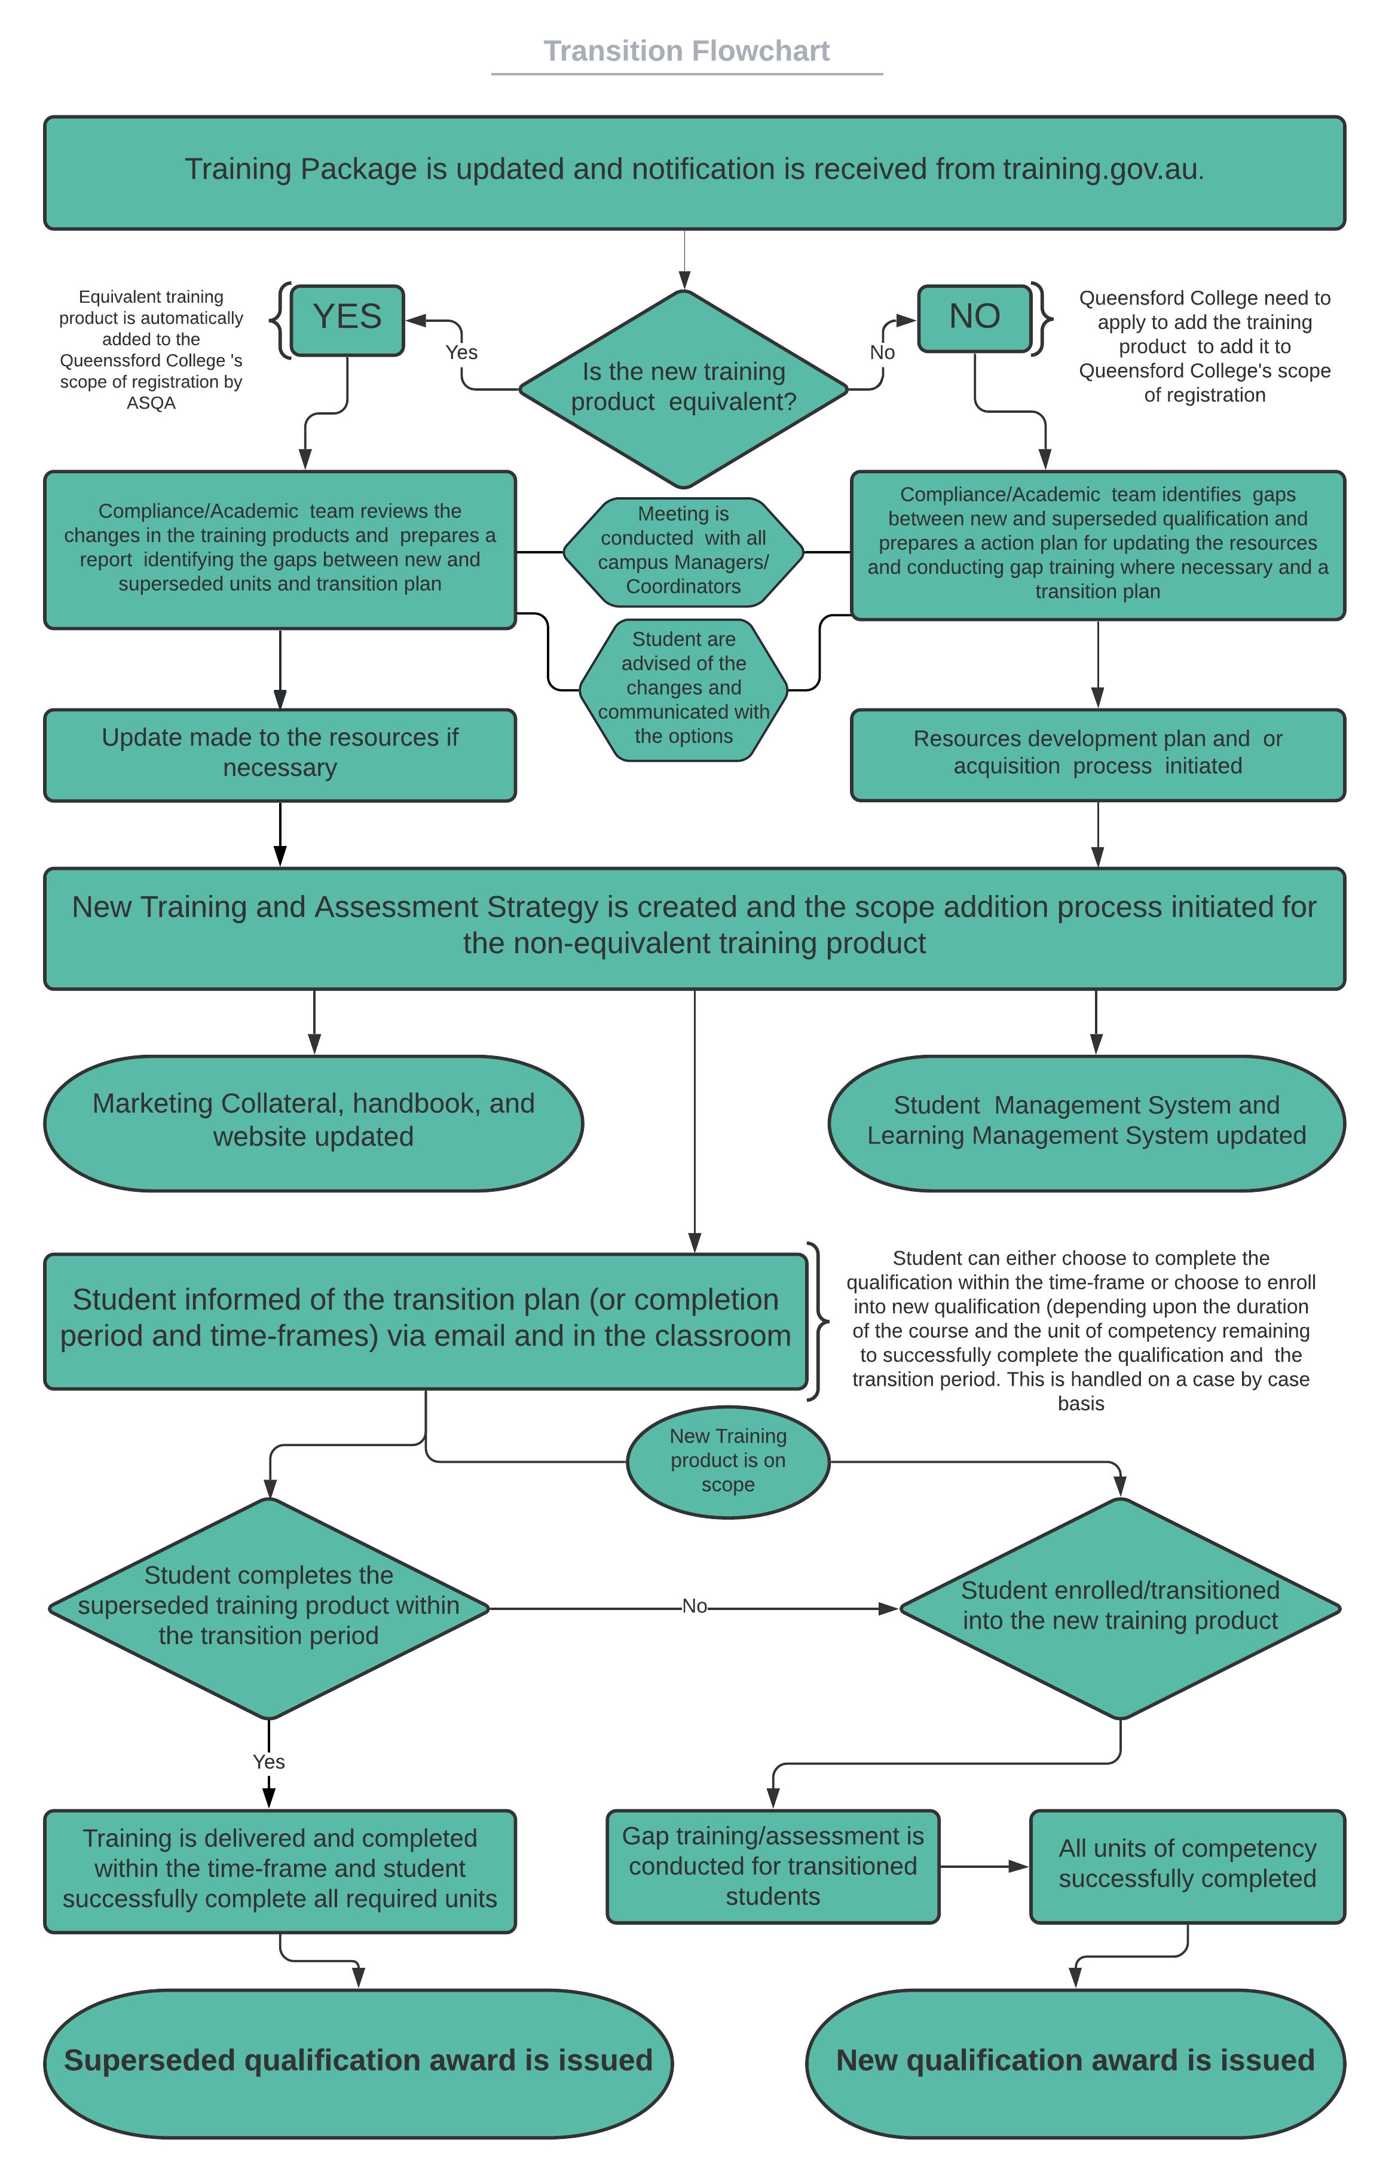

Definitions:
AQF: Australian Qualifications Framework. The framework for regulated qualifications in the Australian education and training system, as agreed by the Australian Government, state and territory ministerial council with responsibility for higher education.
ASQA: Australian Skills Quality Authority. The agency established in 2011 to support the National VET Regulator in their decision-making.
national register: The register maintained by the Australian Government department responsible for VET and referred to Section 216 of the National Vocational Education and Training Regulator Act 2011, located at training.gov.au
new training product: revised training product that is published in the national vet register as a replacement for the superseded training product.
superseded training product: a previously endorsed training product replaced by a newer revised version published in the national vet register
transition period: means, where a training product has been superseded, removed or deleted from the National Register, the allowable timeframe within which the learner’s training, assessment, and AQF certification documentation issuance must be completed or, in the case of a superseded training product, within which the learner is transitioned into the replacement training product.
training product: Qualifications. The glossary in the Standards for Registered Training Organisations 2015 defines the term ‘training product’ as including an ‘Australian Qualifications Framework (AQF) qualification, skill set, unit of competency, accredited short course [or] module’.
training package: The components endorsed by the Australian Industry Skills Committee (AISC) or its delegate in accordance with the Standards for Training Packages. The endorsed components of a training package are:
- units of competency
- assessment requirements (associated with each unit of competency)
- qualifications
- credit arrangements.
A training package also consists of a non-endorsed, quality assured companion volume, which does not form part of the requirements
training and assessment: The training and/or assessment provided to a student by a training provider or its subcontractor in relation to the AQF qualifications and/or units of competency within the training provider’s scope of registration.
VET Regulator: The National VET Regulator (ASQA’s chief executive officer) and/or a non-referring state body responsible for VET.

Associated documents
- Transition plan document template
- Superseded Training and Assessment completion plan document template
- Student Communication letter templates

References and relevant regulations
- General direction_LearnerTransition
- Transition items
- National Vocational Education and Training Regulator Act 2011 (the Act).
- VET Quality Framework
- SRTOs 2015

